

EPROJECT REPORT

FPT APTECH – T2310E



March 24, 2024

Beauti of beaches website

Instructor: Mr. Hoang Duy Nguyen

Member: Pham Quang Huy, Le Hong Hai, Vu Anh Tho, Pham Tuan Hung

Table of Contents

**I.** **Introduction** 3

**II.** **eProject Abstraction** 3

**III.** **Tool and Technology used** 4

**IV.** **User’s Case** 5

**V.** **Site’s map** 6

**VI.** **eProject Analysis and Design** 6

**VII.** **Developer’s Guide** 14

1. Introduction

The primary objective of our website is to showcase various beaches from around the world. The Beauty of Beaches website offers information, images, and services related to these beaches. Users, whether planning a vacation, seeking a getaway, or simply gathering information, can explore our platform to fulfill their needs.

1. eProject Abstraction

***Beauty of Beaches***is a straightforward website featuring detailed information about 11 beaches, including their locations, activities, travel options, services, blogs, and galleries. Our goal is to provide visitors with the most up-to-date information available. Each beach is showcased with authentic images, renowned blogs, and popular services found online.

The website is designed for the Windows Platform using HTML5, CSS, Bootstrap, SASS, Reactjs, Json-server and Geolocation technology. It is optimized to perform well on all major browsers, such as Chrome, IE, and Firefox. Additionally, we aim to enhance user experience by ensuring compatibility with various devices, ranging from smartphones to computers.

After coming to an agreement, we decide that the website will include the following:

1. The layout: This will be consistent across all pages and will include:
   1. Navigation bar
   2. Footer
2. The main pages: These will utilize the layout and render content between:
   1. Homepage
   2. Region page
   3. Beach page
3. The other pages: These will contain different sections gathered from beaches
   1. Blogs
   2. Gallery
   3. About us
4. Tool and Technology used

* For this project, we are utilizing three primary tools:

- Visual Studio Code: This serves as our primary integrated development environment (IDE) for writing and managing code.

- Google Chrome: We use this for testing and debugging the website during development.

- GitHub: Allowing us for collaborative development, code sharing, and version tracking.

* In addition to these tools, we are leveraging the following technologies to achieve our project goals:

- HTML 5: For structuring and presenting content on web pages.

- CSS: For styling and formatting the visual aspects of our website, ensuring a polished and cohesive appearance.

- Bootstrap: For easier styling and formatting website

- SASS: For make writing and maintaining CSS more efficient and expressive

- React.js: For building user interfaces, providing dynamic and interactive elements to enhance the user experience.

- Json-server: For store data and utilizing a fake API to retrieve data from the server.

* Before running the eProject please using command prompt (CMD) to run these following commands:

*npm install*

- This will set up necessary foundation for project include reactjs, json-server,…

*npx –watch src/database/db.json –port3080*

- This will start json-server on port *3080* for project to get data

*npm start*

- This will start the project

1. 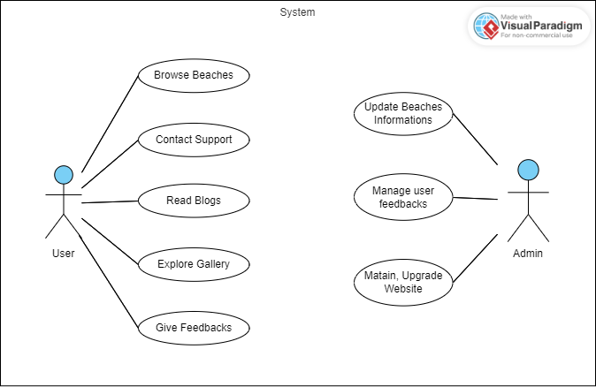User’s Case
2. Site’s map

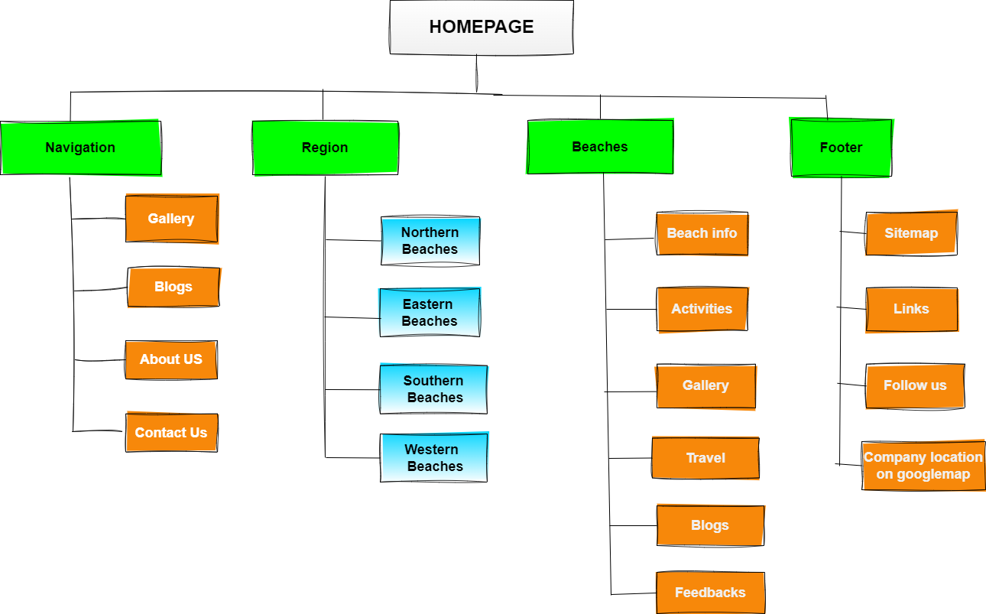

1. eProject Analysis and Design

## 1. The layout:

* The navigation bar:

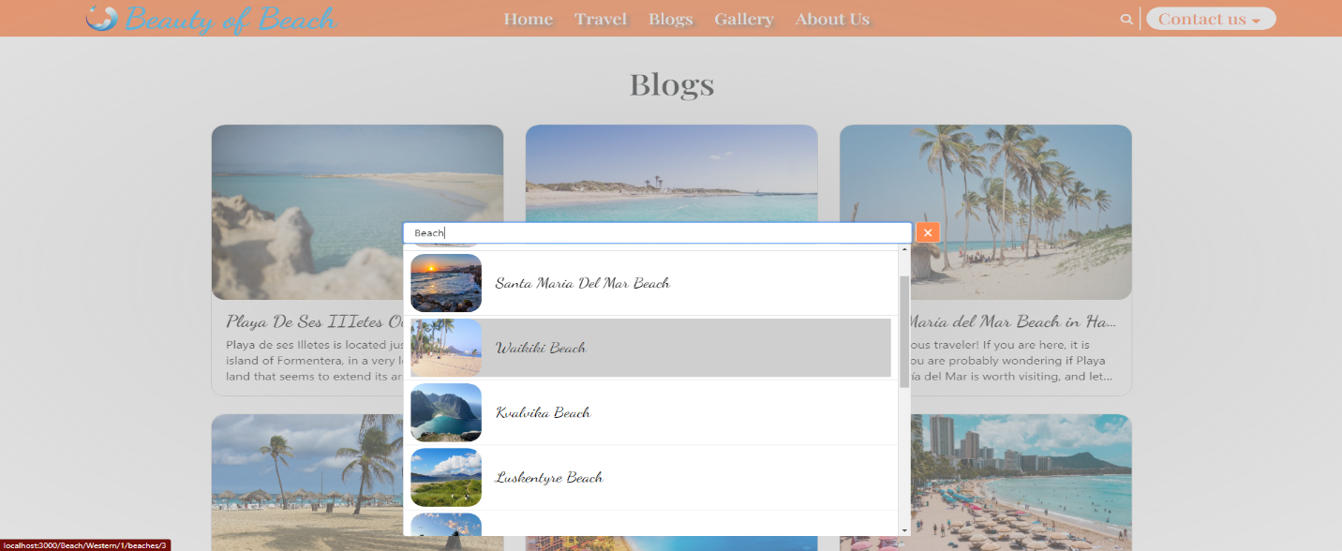- Navigation bar on top of each website including: Website logo, home, travel, blogs, gallery, about us, contact us and search button. The search section for find beaches:

* 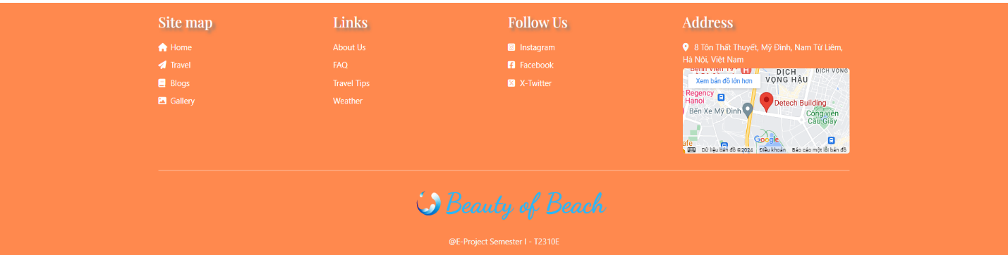The footer:

- The footer is at the bottom of each website including: Sitemap, Links, Follow Us and Address which include Geolocation

## 2. Homepage:

- Upon entering the website, users are greeted with a video presentation and accompanied by a compelling slogan that articulates the primary objective of the website: assisting users in discovering their ideal beaches.

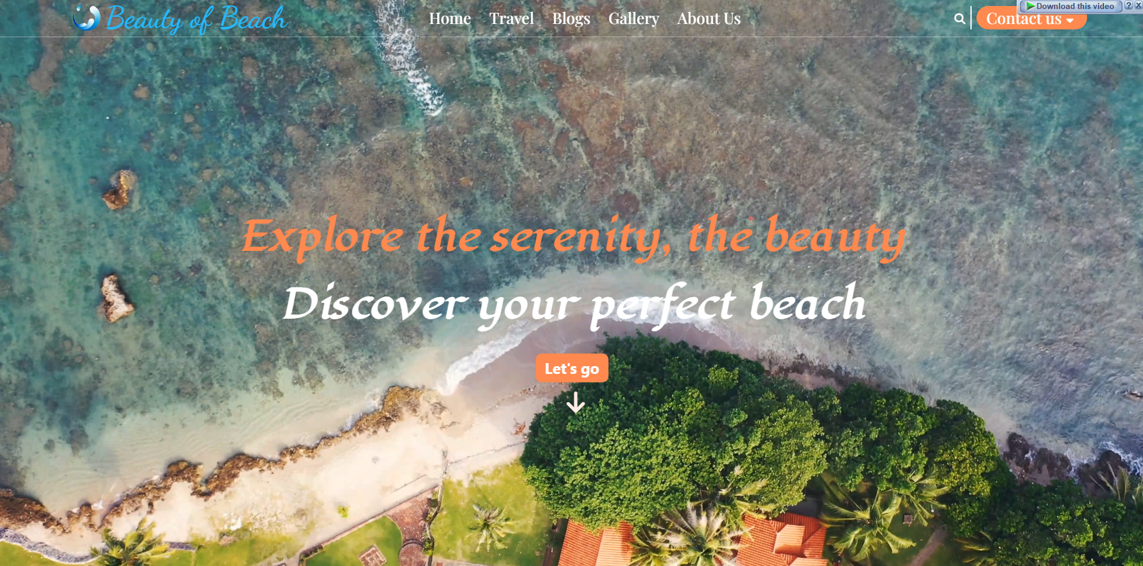

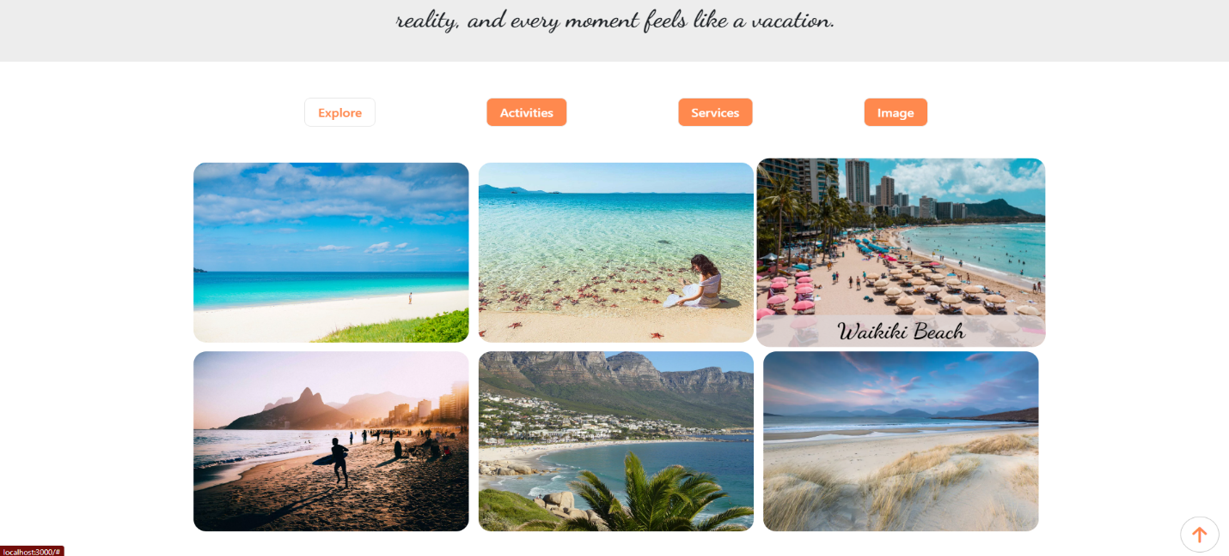- Next up, we have selection site: Explore, Activities, Services and Images. Each of them selects randomly beaches data and show for the users. Moreover, users can click on any of these options to navigate to the dedicated Beach page, where detailed information about the selected beach is provided.

- Finally, users can explore the blog section, where they can access insightful articles and information about various beach-related topics. Additionally, there is a dedicated section for our wishes for user to enhance their experience.

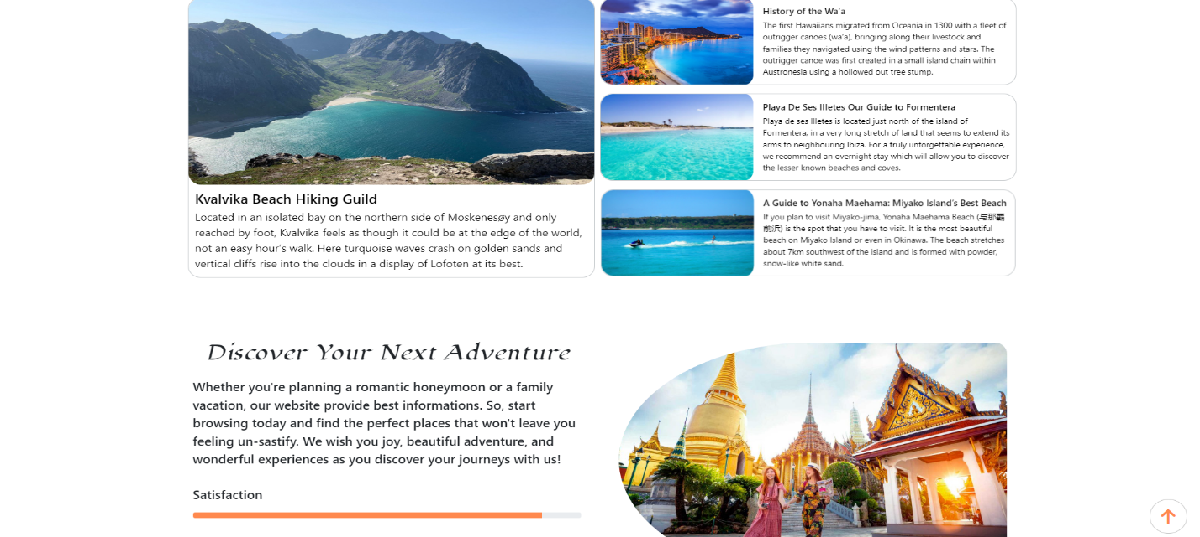

## 3. Region page:

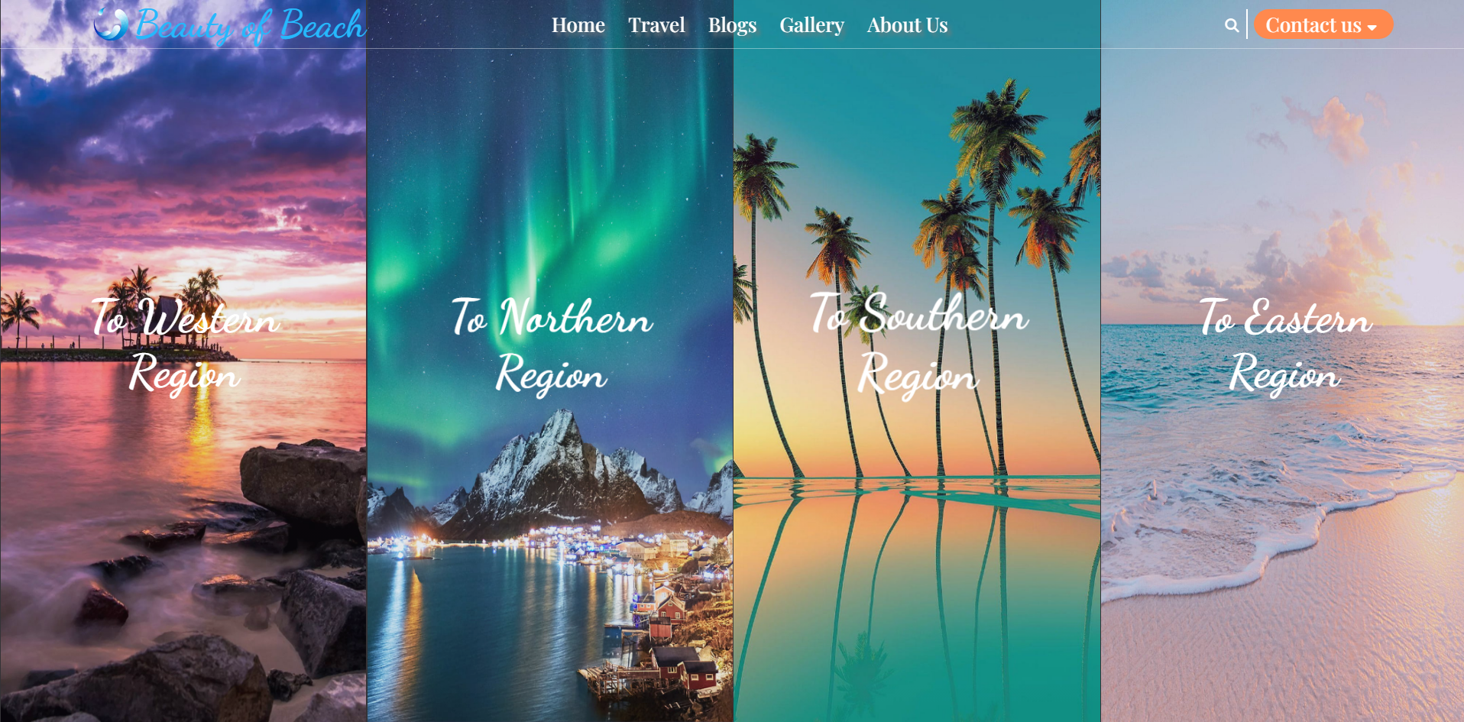

- Upon clicking the "Travel" option in the navigation bar, users are directed to the Region page. Here, stunning images are displayed alongside corresponding links, allowing users to select their preferred region and proceed to explore the beaches within it.

## 4. Beach page:

- The main header of the Beach page will has unique introduction for the beach in selected region.

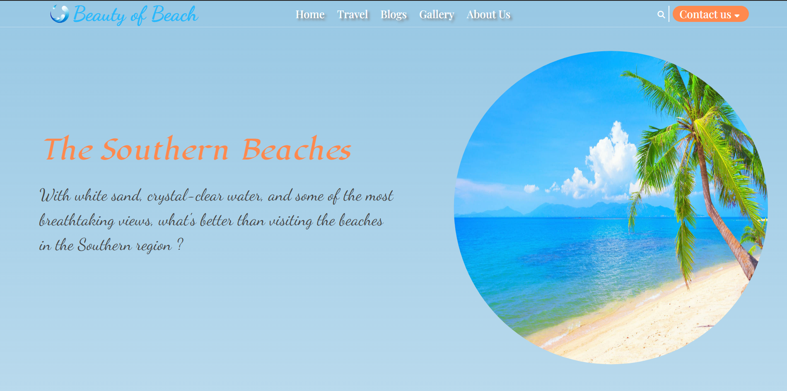

- Next up is a navigation bar act as a scroll-spy and user can select to navigate to different sections. Under is the Explore section contain some info about the beach

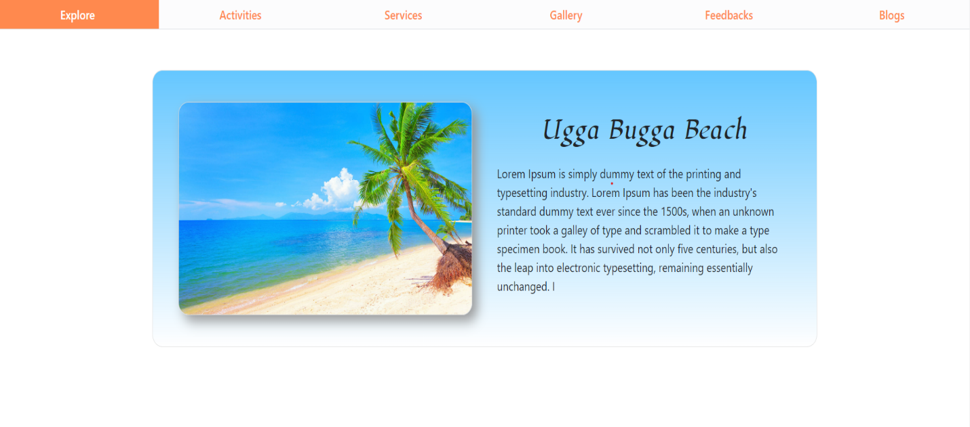

- The Activities section show thing to do in the beach area. User can click “Next” to see other activities.

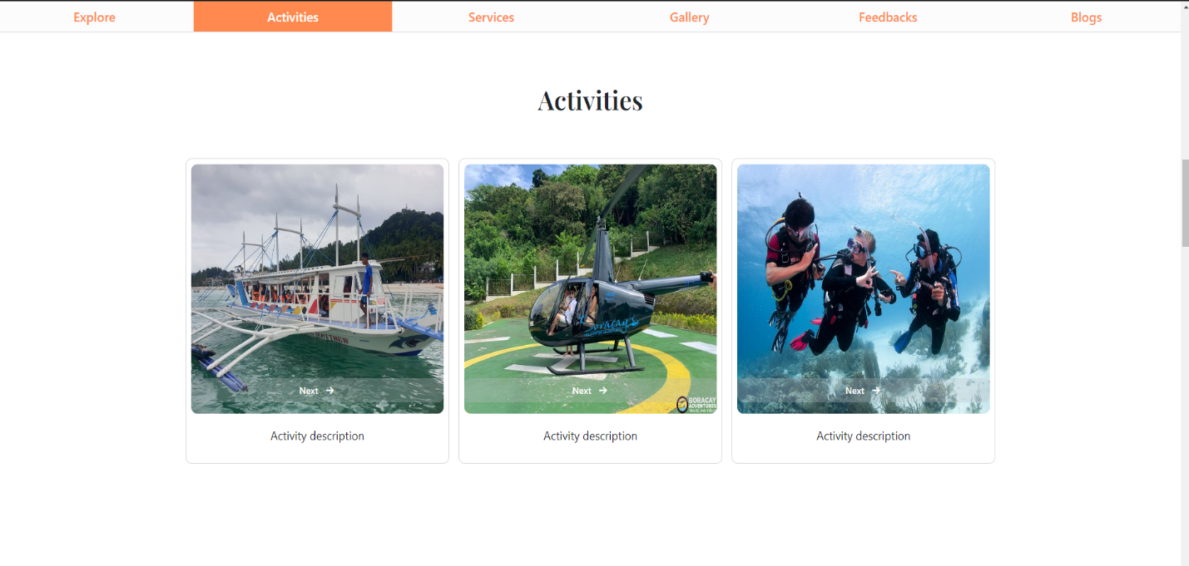

- Next is service section, where user can see famous food, hotel and travel options available at each beach.

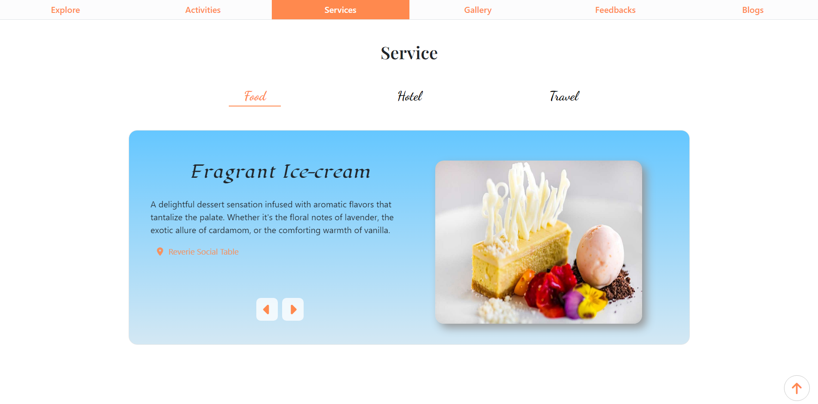

- The Gallery section for viewing different images

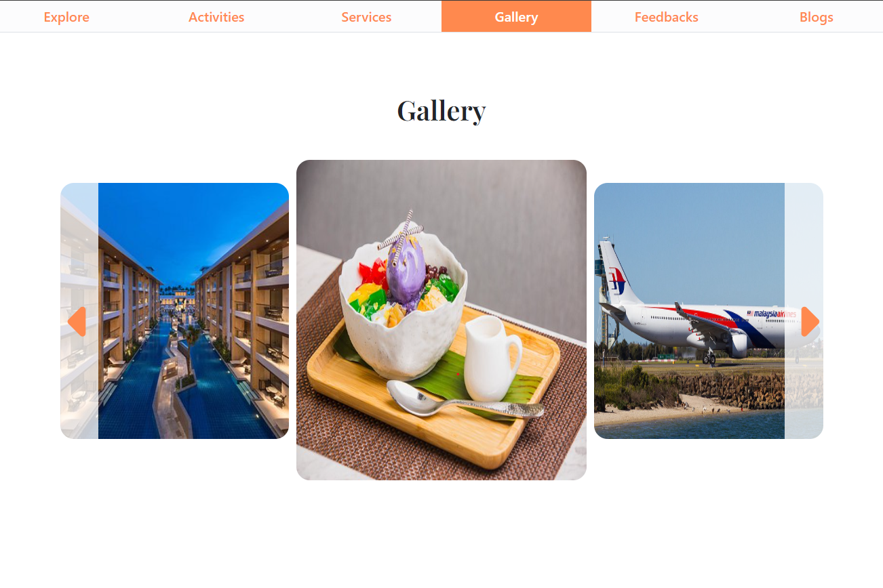

- And next is the user feedback section displays comments from other visitors about the beach. Users can also leave their own comments about the beach.

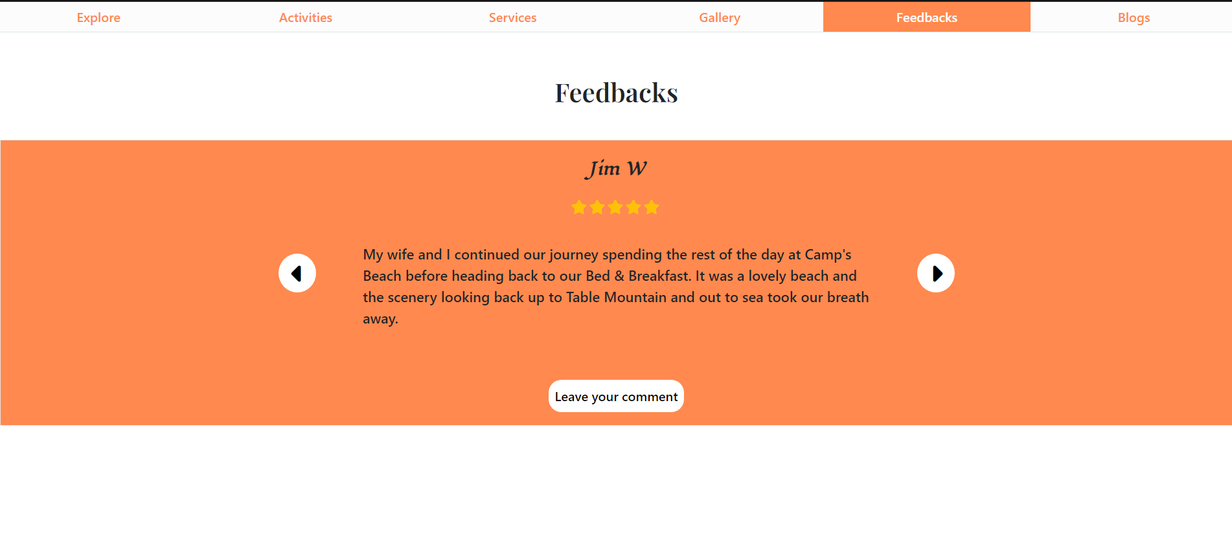

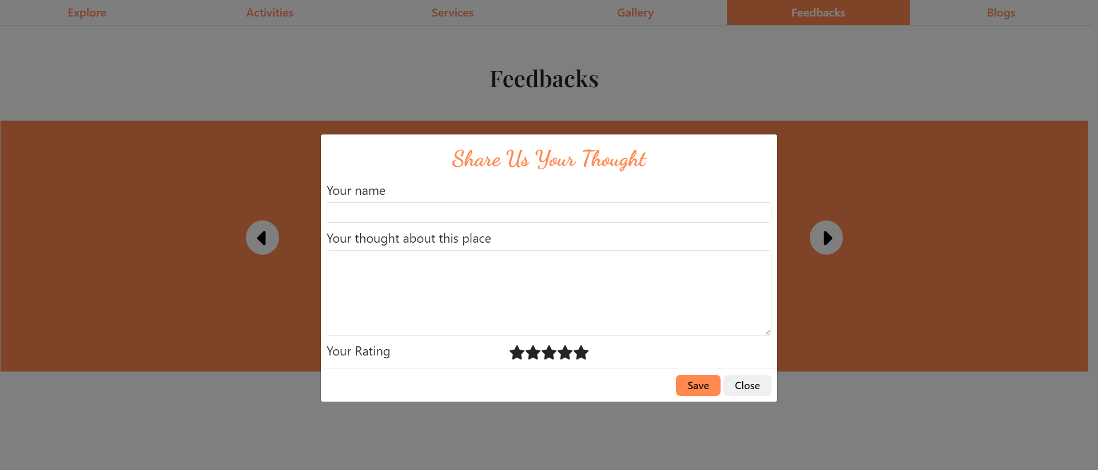

- Finally, the Other Beaches section. User can choose other beaches from the same region and different regions.

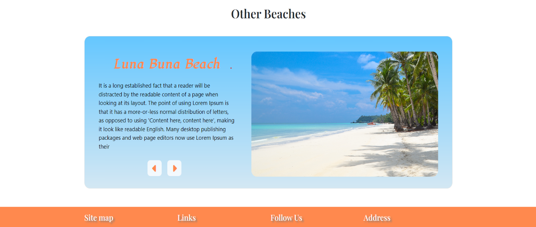

## 5. Other pages:

- Through the selection in the navigation bar, website will redirect user to other pages :

* Blog page : Show all famous blogs.
* Gallery page: Show all images of every beaches.
* About us page: Contain information about website and us – the creator of this website.

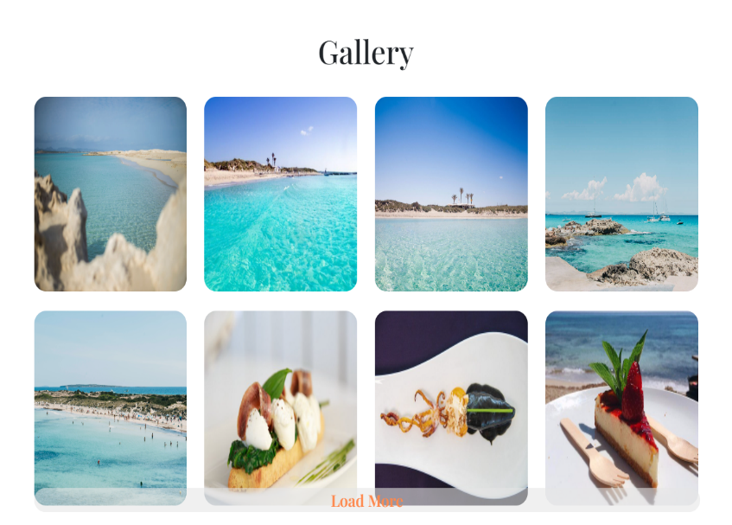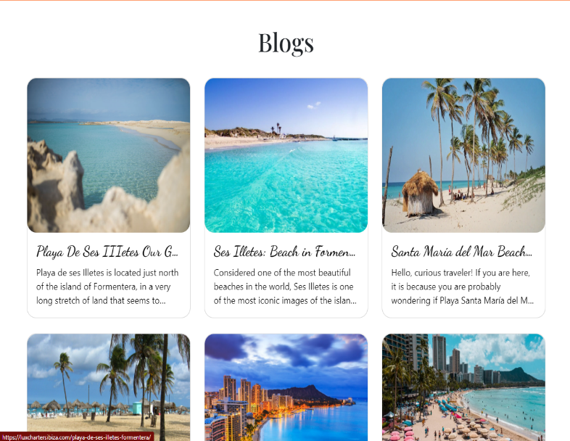

1. Developer’s Guide
2. Hardware requirement

* A minimum computer system that will help you access all the tools in the courses is a Pentium 166 or better
* 64 Megabytes of RAM or better

1. Browser support

* Chrome browser version 57.0 and above.
* Firefox browser version 52.0 and above.
* IE browser version 11.0 and above.